**Docker – Docker Architecture**

The following image shows the standard and traditional architecture of virtualization.The server is the physical server that is used to host multiple virtual machines.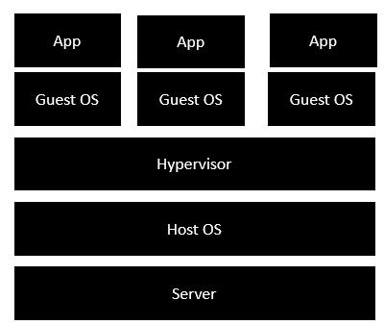

The Host OS is the base machine such as Linux or Windows.

• The Hypervisor is either VMWare or Windows Hyper V that is used to host virtual

machines.

• You would then install multiple operating systems as virtual machines on top of the

existing hypervisor as Guest OS.

• You would then host your applications on top of each Guest OS.

The following image shows the new generation of virtualization that is enabled via Dockers.

Let’s have a look at the various layers.

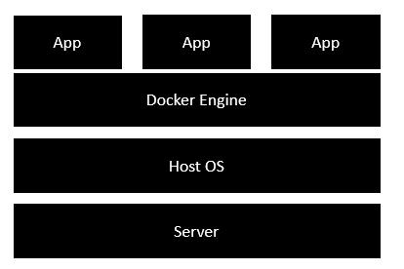

The server is the physical server that is used to host multiple virtual machines. So

this layer remains the same.

• The Host OS is the base machine such as Linux or Windows. So this layer remains

the same.

• Now comes the new generation which is the Docker engine. This is used to run the

operating system which earlier used to be virtual machines as Docker containers.

• All of the Apps now run as Docker containers.

The clear advantage in this architecture is that you don’t need to have extra hardware for

Guest OS. Everything works as Docker containers.